National Programme of Training
for
Boards of Management of Primary Schools

Handout
Board Finances & the Role of Treasurer

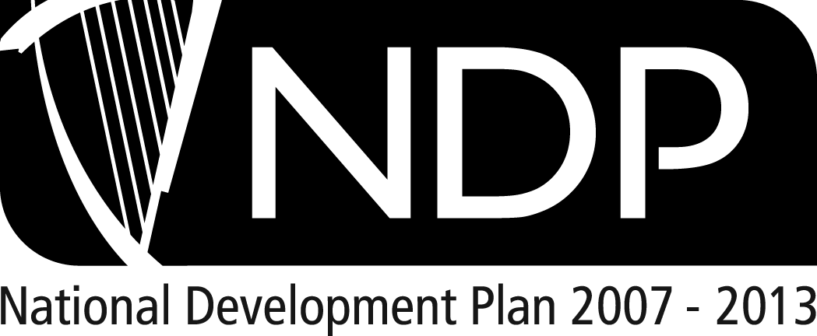   |  | 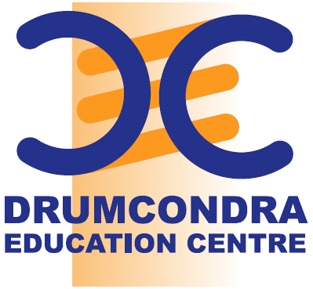
  AN ROINN  OIDEACHAIS  AGUS EOLAÍOCHTA | DEPARTMENT OF  EDUCATION  AND SCIENCE

2008
Slide 2 |  | Slide 3
Slide 4 |  | Slide 5
Slide 6 |  | Slide 7
Slide 8 |  | Slide 9
Slide 10 |  | Slide 11
Slide 12 |  | Slide 13
Slide 14 |  | Slide 15
Slide 16 |  | Slide 17
Slide 18 |  | Slide 19
Slide 20 |  | Slide 21
Slide 22 |  | Slide 23
Slide 24 |  | Slide 25
Slide 26 |  | Slide 27
Slide 28 |  | Slide 29
Slide 30 |  | Slide 31
Slide 32 |  | Slide 33
Slide 34 |  | Slide 35
Slide 36 |  | Slide 37
Slide 38 |  | Slide 39
Slide 40 |  | Slide 42
Slide 43 |  | Slide 44

Organisations and Acronyms
Organisations
Board of Education | Church of Ireland Board of Education,  Church of Ireland House,  Church Avenue, Rathmines, Dublin 6  Tel: 01 497 8422
CPSMA | Catholic Primary School Management Association,  St Patrick’s College, Maynooth, Co Kildare  Tel: 1850 – 407200  email: info@cpsma.ie  website: www.cpsma.ie
DES | Department of Education and Science,  Marlborough St., Dublin 1  Tel: 01 889 6400  email: info@education.gov.ie  website: www.education.ie
Educate Together | Educate Together,  H8a Centrepoint,  Oak Drive, Dublin 12  Tel: 01 429 2500  email: info@educatetogether.ie website: www.educatetogether.ie
Foras Pátrúnachta | Foras Pátrúnachta na Scoileanna Lán-Ghaeilge Teo,  92 Bóthar Sheannaigh,  Rath Éanaigh, BAC 5  Tel: 01 8314487  email: foraspatrunachta@hotmail.com  website: www.foras.ie
IMPACT | Trade Union: www.impact.ie
INTO | Irish National Teachers Organisation: www.into.ie
IPPN | Irish Primary Principals’ Network: www.ippn.ie
NABMSE | National Association of Boards of Management in Special Education,  Kildare Education Centre, Friary Rd, Kildare, Co Kildare.  Tel: 045 533 753  email: nabmse1@eircom.net  website: www.nabmse.org/
NCCA | National Council for Curriculum and Assessment,  24 Merrion Square, Dublin 2  Tel: 01 661 7177  email: info@ncca.ie  website: www.ncca.ie
NCTE | National Centre for Technology in Education,  Dublin City University, Dublin 9.  Tel: 01 700 8200  email: info@ncte.ie  website: www.ncte.ie
NCSE | National Council for Special Education,  1-2 Mill Street, Trim, Co. Meath.  Tel: 046 948 6400  email: info@ncse.ie  website: www.ncse.ie
NEPS | National Educational Psychological Service,  Frederick Court, 24/27 North Frederick St., Dublin 1  Tel: 01 889 2700  website: www.education.ie
NEWB | National Education Welfare Board,  16-22 Green Street Dublin 7  Tel: 01 8738700  email: info@newb.ie  website: www.newb.ie
PPDS | Primary Professional Development Service,  Dolcáin House,  Monastery Road,  Clondalkin, Dublin 22  Tel: 01 464 2227
SESS | Special Education Support Service,  Cork Education Support Centre,  The Rectory, Western Rd, Cork.  Tel: 1850 200 884  email: info@sess.ie  website: www.sess.ie
Teaching Council | The Teaching Council,  Block A,  Maynooth Business campus,  Maynooth,  Co. Kildare  Tel: LoCall 1890 224 224, 01 651 7900  email: info@teachingcouncil.ie  website: www.teachingcouncil.ie
Teacher Education Section (TES) | Teacher Education Section,  Department of Education & Science,  Marlborough St.,  Dublin 1  This unit has a role in all national initiatives
Acronyms
AP | Assistant Principal
BOM | Board of Management
DP | Deputy Principal
DEIS | Delivering Equality of Opportunity in Schools – an action plan for educational inclusion
Early Start | The Early Start Programme is a one-year programme offered to children aged 3-4 years in selected schools in areas of designated disadvantage
HSCL | Home School Community Liaison
IEP | Individual Educational Plan
Inspector | Department of Education and Science inspector
IPLP | Individual Profile and Learning Programme
Mainstream Teacher | Class teacher
NABMSE | National Association of Boards of Management in Special Education
NPC | National Parents Council
NQT | Newly qualified teacher
PA | Parent Association
Partners | Parents, Board of Management etc. involved in a school’s activities
Patron | Schools operate under a patron body e.g. Catholic Church, Educate Together, Church of Ireland Board of Education, An Foras Pátrúnachta, Islamic Board of Education …
PoR | Post of Responsibility e.g. deputy principal, assistant principal, special duties teacher
RTT | Resource Teacher for Travellers
SDP Day | Each school has sanction to close for one day to engage in planning activities
SENO | Special Education Needs Organiser
Shared teachers | Teachers working in a number of schools to support children with special needs
SIPTU | Trade Union
SNA | Special Needs Assistant
Special duties teacher | Teachers with a special responsibility for organisational or curriculum issues in addition to their teaching duties
Trustees | The persons nominated by the Patron as trustees of the school. They are parties to the lease of the school premises. The Trustees undertake that the buildings shall continue to be used as a national school for the term of the lease & guarantee that the premises and contents are insured
Visiting teachers | Teachers working with pupils who are sensory impaired
VTT | Visiting Teacher for Travellers

