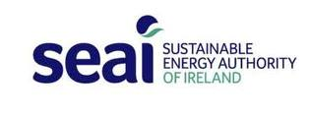 |  | 

Invite you to participate in series of Energy Management Workshops

ENERGY MANAGEMENT

learn how to save your school money & help the environment | see www.energyineducation.ie



Sustainable Energy Authority of Ireland and Department of Education are holding Energy Management workshops in your area.
- Learn to reduce your energy use & create a culture of energy efficiency
- Energy Management quickly delivers low or no cost energy savings
- This proven programme also assists with Grants, Display Energy Certs & other legal requirements

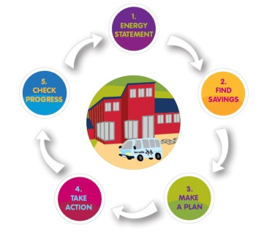
What is involved?
- Attend two ½ day workshops using guides & workbook through a five step energy management process
- Access to resources, online tools and expert advice
- Have opportunities to network , share knowledge & experiences with other participants
This is a series of two workshops
- Workshop 1 – Analyze your Energy Consumption & identify opportunities to save
- Workshop 2 - Develop & implement your Energy Savings Plan & Reviewing your plan

When will it be?

How to Register?
Complete form & email to ldunne@cpsma.ie

Location: TBC
Time: Day 1 (9.30 -13.30) Day 2 (9.00 – 13.00)
Date Feb/March 2013
Fee: Free of Charge
Date of Day 2 arranged on Day 1

Commitment
The commitment and participation of each individual plays a vital role in the overall success of the Energy Management Training Programme.

Agreement
Participants to the programme must agree to the following to qualify for this workshop:
- Take Action – Be Interested in Saving Energy & motivated to save.
- Attendance – Attend all two workshops.
- Time – Assign appropriate time and resources to complete the assignments.
- Engage – Actively engage in the programme and initiate improvements.
- Data Collection – Gather data and provide this as part of the programme.
Data will be treated confidentially and only reported as collated data without specific details
- Feedback and Information Sharing - Provide feedback on issues, progress and performance & share information and experiences.

What to bring?
- Energy Bills - participants are asked to bring their energy bills (electricity, Gas, Heating Oil etc)
- Floor area - approximation on the floor area of their place of work (in m² or ft²).

School Name: |  |  | Roll Number:
Address:
Phone Number: |  |  | Principal
Email: |  |  | No. of employees: |  |  | No. Of Students:
School Representative to Attend (Only one representative per school)
Name: |  |  | Position in School:
Phone / mobile: |  |  | Email:
Knowledge Level of Energy Management
Please tick one of the following | New to Energy Management  |  | Limited Knowledge  |  | Advanced Knowledge 
Energy Spend (use total costs from last available year)
Electricity | € |  |  | Do you have internet access to your bills? Y / N
GasOil / heating oil | € |  |  | If Yes, Username: |  |  | Password:
Gas | € |  |  | Other fuels e.g. LPG, |  |  | €
Area of Interest (these will be addressed on the day & also reviewed by SEAI Expert Advisors)
Questions? |  |  | Areas of Interest?
School Commitment
On behalf of:  (Insert participant name) |  |  |  | Name of Principal/CEO*:
I wish to apply to join this programme based on the criteria of participation as outlined above. |  |  |  | Job Title:
Signature: |  |  |  | Date:
*The person who has authorisation to release you to attend the courses and implement the assignments.


Visit www.seai.ie
- Energy Management Pack
- Case Studies
- Video Guides Top Tips & Handy Guides
- Display Energy Management Information
- ‘Energy Wise’ Newsletter
see also www.energyineducation.ie

