Interested in reducing your
school’s energy costs?
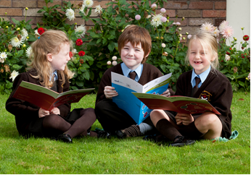

Sign up today for a free training course to find out how you could save money by better managing your school’s energy use.

Over 90 CPSMA member schools have already registered with Energy in Education. The programme offers a range of supports developed by the Sustainable Energy Authority of Ireland (SEAI) in collaboration with the Department of Education and Skills designed to help schools to improve energy management practices, reduce school operating costs and protect the environment.

Find out how to save energy

The Energy in Education website www.energyineducation.ie offers a range of factsheets, videos and on-line energy management tools as well as case stories from a range of school including St Clare’s primary School, Harold’s Cross, Dublin.

Attend an energy management course

More than 200 schools from all over Ireland have already taken part in Energy Management courses. Participants are guided step by step through the energy management process from understanding bills and energy use in the school to developing and implementing an energy saving plan.

The course involves attending two half-day workshops where schools are given access to a range of resources, online tools, expert advice and opportunities to network and share knowledge & experiences with other schools.

Schools that attend courses can apply for an Assessment, Mentoring and Advice (AMA) service, including a site visit and report to assist in identifying and implementing energy saving opportunities.

Book a course now!
CPSMA are among the stakeholders working in partnership with the Energy in Education Programme to offer Energy Management courses. To register contact ldunne@cpsma.ie

‘I went in knowing nothing about how to manage my energy costs and was delighted to hear such basic tips for energy saving that I hadn’t thought of. I didn’t know how to monitor our energy use until I heard about the energy monitor so I am getting one. I learned how important it is to raise awareness and have staff, pupils and the whole community involved. I was delighted I decided to go as there are so many low cost things we can be doing to save money on our energy bills’.

Breda Murphy, Newcastle NS, Athenry, Co Galway.

To save your school energy and money visit www.energyineducation.ie

