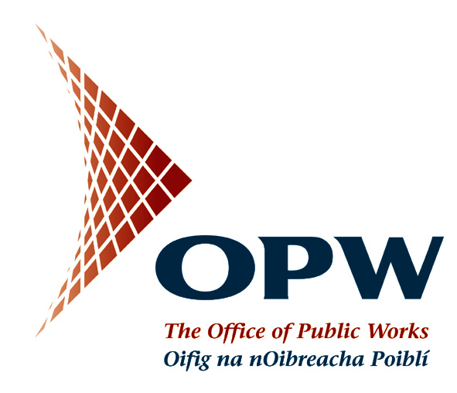

Notification from the National Procurement Service of the Office of Public Works

and

The Department of Education and Skills

Results of the Schools Electricity Procurement Competition

For the attention of Managerial Authorities of Recognised Primary, Secondary, Community and Comprehensive Schools
I am contacting you to update you on the results of the recent electricity procurement competition for primary and second level schools.

As you know, the National Procurement Service (NPS) of the Office of Public Works has run a procurement competition for electricity on behalf of 1,870 schools. The NPS recently sought tenders from electricity suppliers and the overall results of the competition are set out below and in the attached documents.

SAVINGS ON THE COST OF ELECTRICITY
The competition results show that schools can achieve significant savings on the cost of electricity, compared to their current costs, if they avail of the rates that are available from the NPS centralised procurement competition.

The overall electricity competition can be summarised as follows:

No of Schools in competition: 1,870
No of Lots*: 10

Total % saving per annum: 10%

Current electricity costs per annum: €10.473 million

Value of Savings per annum: €1.025 million

*For the purposes of the competition, school sites were assigned to groupings (lots) according to their profile of electricity consumption.

WHAT THIS MEANS FOR YOUR SCHOOL
The file attached to this email shows the rates (unit rate, standing charge, electricity tax, etc.) obtained in the electricity procurement competition. These rates can be compared to the rates on your most recent electricity bill. Please note, however, that there have been increases in electricity costs effective from 1st of October, 2013. For the purposes of comparing rates it is therefore important that a bill for the period post 1st of October, 2013 is used.

Please note that this offer was assessed by the NPS as being the lowest priced offering for this lot and it is recommended that your school sign up for this offer.

Please note that the competition rates are confidential and commercially sensitive and must not be divulged to a third party.

The competition for this lot has been won by Electric Ireland.

Supplier | Contact Person | E-mail
Electric Ireland | Gerard Hensey | gerard.hensey@electricireland.ie

WHAT YOU NEED TO DO NOW
A two-year contract is attached to this email and you need to PRINT, COMPLETE, SIGN and RETURN the contract to the NPS by the 4th of December, 2013. The relevant parts of the contract for your completion are marked with (X).

The contract should be sent to the following address:

National Procurement Service,
C/O Kenneth Shanley,
Office of Public Works Head Office,
Jonathan Swift Street,
Trim,
Co. Meath.

WHAT HAPPENS WHEN THE CONTRACT IS RETURNED
When the NPS receive your school’s contract, it will be processed and forwarded to your electricity supplier to countersign and to effect the changeover to the competition rates from 1st January, 2014. Your electricity supplier may be in contact with you in relation to obtaining a meter reading. A guide to reading your meter is attached for information.

Should you have any queries in relation to this competition please contact the NPS at schoolelectricity@opw.ie. The overall competition results have also been made available to your school management body as they are working with the Department and the NPS on the implementation of this competition.

The Energy Advisor to the NPS – Schneider Electric – is assisting with the implementation of the competition and may be in contact with you in regard to this competition.

OTHER WORK THAT IS UNDERWAY TO ACHIEVE FURTHER SAVINGS ON ELECTRICITY
A review will also be conducted of the maximum import capacity of schools and this will identify where there are opportunities to change MIC levels which will help to reduce costs further. In some cases, the MIC may be set higher than required, particularly where energy efficiency measures have been implemented in schools in recent times. The NPS will be in contact with those individual schools in the coming weeks to advise if further savings can be achieved.

FURTHER INFORMATION ON PROCUREMENT
The Department of Education and Skills has recently issued a circular 0060/2013 which provides further information on public procurement. The circular and other information is available on the Department’s website www.education.ie.

Kind regards,

