Board of Management Training Notes
Child Protection Procedures for Schools 2025
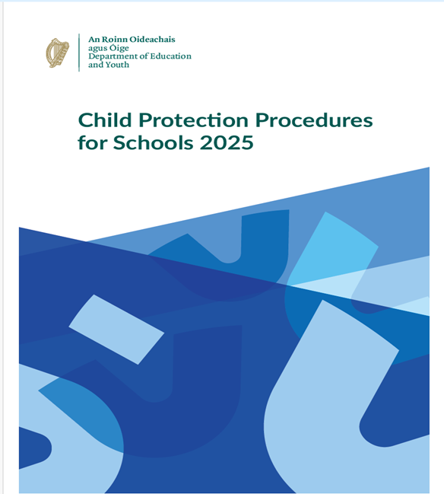
Oversight • Safeguarding • Confidentiality
These notes support Boards of Management in understanding and fulfilling their statutory role in child protection and safeguarding.
It is designed to accompany Board training and reflects the requirements of:
• Children First Act 2015
• Child Protection Procedures for Schools 2025
The primary focus throughout is the welfare and safety of children, and the Board’s role in oversight — ensuring that procedures are followed, without investigating individual cases.

Visit www.cpsma.ie for the latest training webinars and videos.

For guidance and support, Boards are advised to contact:
Catholic Primary School Management Association (CPSMA)
Advice Line: 01 629 2462
Child Protection Procedures for Schools 2025

https://www.gov.ie/en/department-of-education/policy-information/child-protection-procedures-in-schools/

Chapter 1 – Legal Framework
Sets out the laws underpinning child protection in schools:
Child Care Act 1991, Children First Act 2015, Criminal Justice Acts, Sexual Offences Act 2017, Coco’s Law 2020, OSMR Act 2022, Vetting Acts 2012–2016, FOI Act 2014.
Boards must comply with this legal foundation in all child protection matters.

Chapter 2 – Definition & Recognition of Abuse
Explains the four categories of abuse: neglect, emotional, physical, sexual.
Key principle: Tusla must be informed where there are reasonable grounds for concern.
No proof needed — Tusla assesses the concern.

Chapter 3 – Retrospective Allegations
Deals with disclosures by adults about abuse in childhood.
Must be handled sensitively.
If the alleged abuser poses a current risk, it must be reported to Tusla (and possibly Gardaí).
Such cases must be included in the Child Protection Oversight Report (CPOR).

Chapter 4 – Roles and Responsibilities
Duties of all school personnel: report concerns immediately to the DLP.
Board of Management: Appoint DLP and DDLP, ensure procedures are known and implemented, oversee compliance.
DLP/DDLP: First contact for concerns, record-keeping, reporting to Tusla, supporting children.
Patrons: Receive copies of CSS and annual review; must be informed if BOM fails to act.

Chapter 5 – Reporting of Concerns
Outlines how concerns must be reported:
By parents about their own child.
By others (parents, students, community) about another child.
Always go to the DLP (or Chairperson if DLP is the subject).
Parents/others can also report directly to Tusla.

Chapter 6 – How to Make a Report to Tusla
Reports made through Tusla’s secure web portal.
Urgent cases: by phone, followed by written report.
If Tusla unavailable and child is in immediate danger, contact An Garda Síochána.
Schools must know local Tusla contact details.

Chapter 7 – Allegations Regarding School Employees
Child’s welfare is the priority; staff member treated fairly.
Employers must take protective measures (e.g., temporary absence of staff).
Confidentiality is essential.
DLP must inform the employee privately, give details, and outline supports.
Immediate Action Protocol allows precautionary steps before investigations are complete.

Chapter 8 – Record Keeping
Every child protection concern generates a hard copy case file kept securely by the DLP.
Digital drafts must be deleted.
BOM receives only redacted/anonymised reports.
All copies distributed to the Board must be collected and destroyed.

Chapter 9 – Child Safeguarding Statement (CSS) & Risk Assessment
BOM must adopt, publish, and display the CSS and risk assessment.
Annual review required, with stakeholder feedback.
Must be available to parents, patrons, DEY, and on school website.
Also requires student-friendly version displayed in school.

Chapter 10 – Recruitment & Vetting
Schools must comply with Garda Vetting Acts.
Always seek references, especially from last employer (though not legally required to respond).
Additional checks for staff who lived in EU/UK (extra 10–20 working days processing).

Chapter 11 – Training & Supports
All school staff must attend child protection training every 3 years.
DLP and DDLP require specific training.
Refusal to attend may be a disciplinary matter.
BOM must ensure training records are kept.

Chapter 12 – Oversight (CPOR)
BOM must ensure procedures are fully implemented.
CPOR is a standalone agenda item at every meeting.
Covers allegations, concerns, bullying, reporting data.
BOM role: check compliance, not investigate.
Breach of confidentiality can lead to removal from Board and possible personal liability.

Chapters most relevant to the Board of Management

Chapter 4 – Roles and Responsibilities
BOM must appoint a DLP and DDLP.
Ensure they are supported and procedures are followed.
Ensure all staff are familiar with child protection procedures.
Patron oversight link also set out here.

Chapter 7 – Allegations Regarding School Employees
BOM has duties as the employer.
Must ensure protective measures for children, treat staff fairly, seek legal advice, and follow correct protocols.

Chapter 8 – Record Keeping
BOM only sees redacted/anonymised reports.
BOM must ensure strict confidentiality and proper handling of documents.

Chapter 9 – Child Safeguarding Statement (CSS) & Risk Assessment
BOM must formally adopt, publish, and review the CSS.
Responsible for annual review, stakeholder input, and ensuring display/public availability.

Chapter 11 – Training & Supports
BOM must ensure all staff (including DLP/DDLP) attend child protection training every 3 years.
Keep training records.

Chapter 12 – Oversight (CPOR)
Most central chapter for BOM.
CPOR must be a standalone item at every meeting.
Oversight role only — verifying compliance, not investigating cases.
BOM members must maintain strict confidentiality; breaches can lead to removal and personal liability.

This Photo by Unknown Author is licensed under CC BY



Oversight – What does it look like?

In ordinary terms, oversight means asking questions at Board meetings like:

Have the procedures been followed?
Has the DLP sought advice or made a report where required?
Are records being kept securely and confidentially?
Are the right people trained, appointed, and supported?
The Designated Liaison Person – usually the Principal manages cases.
Tusla investigates.
The Board checks that the process was followed.

Practical examples of appropriate oversight questions at a Board meeting:

Board members may (and should) ask questions that test whether procedures are working, while avoiding any discussion of case details.

Examples include:

Have the Child Protection Procedures for Schools 2025 been formally adopted and minuted by the Board?
Are the Designated Liaison Person (DLP) and Deputy DLP properly appointed, trained, and supported?
Is SPHE, including the Stay Safe Programme, being implemented across all classes in line with Department requirements?
Have all staff and relevant volunteers completed mandatory child protection training within the required timeframe?
Is the Child Safeguarding Statement and Risk Assessment up to date, reviewed annually, and publicly displayed?

Questions relating specifically to cases presented in the Child Protection Oversight Report– focusing on procedure only:

Has the DLP sought advice from Tusla where required?
Where advice was sought, was it followed correctly and within the appropriate timelines?
Are records being kept securely and in line with the Procedures and data protection requirements?
Is the Board satisfied that confidentiality is being maintained at all times?
If the DLP has decided not to take advice from Tusla, what safeguards are in place?

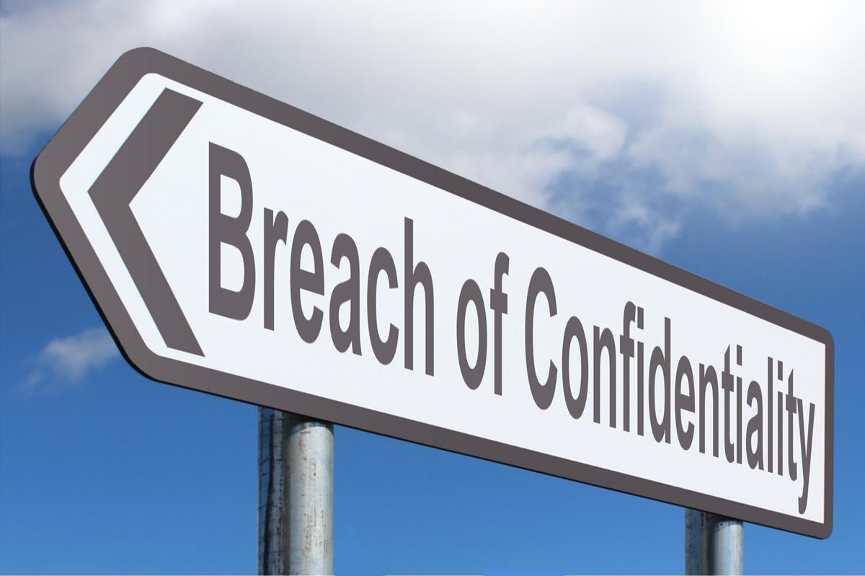

Confidentiality – What does it look like?

Scenario
A parent approaches you and says:
“I heard there was a child protection issue in the school.”
.
Positive, Proportionate Responses

Board members should respond neutrally and reassuringly, without confirming, denying, or exploring the comment.

Appropriate responses include:

“I wouldn’t be aware of anything like that, but the school has clear safeguarding procedures in place, and they’re followed at all times. If you have a concern, the right person to contact is the Principal or the Designated Liaison Person.”

“Board members don’t get involved in individual matters, but safeguarding is taken very seriously in the school.”

“If a parent ever has a concern, the Principal or the Designated Liaison Person is always the right person to speak to.”

“I’m not in a position to comment on school matters, but be assured, the school has strong child protection systems in place.”

Other suggestions when approached by a parent or member of the community:

“I’m sorry, I can’t discuss any matter relating to the Board or the school — those are confidential.”
“I understand your concern, but safeguarding matters are always dealt with through the proper procedures. It wouldn’t be appropriate for me to comment.”
“I’m not in a position to speak about that. If you have a concern, the right person to contact is the Principal or the Designated Liaison Person.

When asked by a staff member or friend in the school:

“Board business is confidential, so I can’t talk about that outside a formal meeting.”
“It’s really important that I protect everyone’s privacy — so I’m not able to discuss Board issues, even informally.”
“Please don’t be offended — I’m not being secretive, just following our child protection procedures.

When you overhear or are drawn into gossip:

“I’m going to step away from this conversation — it’s not appropriate for me to hear or discuss school matters outside the meeting.”
“That’s not something I can comment on, and I’d rather not speculate.”
“If there’s a genuine concern, it should go directly to the Principal or DLP — that’s the right channel.

When another Board member shares too much detail:
“Can I just pause us there? I think we might be moving into information that’s confidential to the DLP — maybe we could keep it general.”

“Let’s remember our role is oversight, not investigation — we don’t need those details.”
“For everyone’s protection, we should keep this discussion at the level of process, not personal information.”

When asked by media or an external person (e.g. patron, inspector, Gardaí):

“All media or official queries are handled by the Chairperson or Principal. It wouldn’t be appropriate for me to comment.”
“The school always cooperates fully with the authorities, but as a Board member, I can’t discuss individual cases.”

When asked by a parent about a report or allegation:

“I know it’s hard not to know details, but for everyone’s safety and fairness, we have to keep all such matters confidential.”
“The school follows the national Child Protection Procedures for Schools 2025. That ensures every concern is handled properly.

Scenario

The Helpful Intention

A Board member wants to “check in” on a family after hearing that a report was made, thinking it would be a kind gesture.
Question:
Why is that a breach, even though the intention is good?
Key points:
It could identify the child or the concern.
It may interfere with a Tusla or Garda process.
It risks retraumatising the family or compromising confidentiality.
Even well-meaning actions can undermine the safeguarding process.

Closing reminder for Boards: Confidentiality isn’t about keeping secrets — it’s about protecting trust. When we hold information carefully, we protect children, respect staff, and honour the role of the Board

Chairperson Flowchart – Child Protection Procedures 2025
Children’s safety and welfare are the primary concerns at all times.
CPSMA Advice Line: 01 629 2462

PATH A – Allegation Against School Personnel (NOT the DLP)

Allegation / Suspicion Arises against School Personnel
CHILD SAFETY FIRST
Is any child at immediate risk?
→ Take urgent protective action if required

If the allegation reported to DLP……….
Remember the DLP records concern and consults Tusla
Reports to Tusla / Mandated report as required
Informs Employer (Chair and Board)
Chairperson – Is there an employment issue? Are protective measures required?
Contact CPSMA – 01 6292462
If the Chairperson has an issue with DLP action?
(No report / No Tusla advice / Ignored advice / Parent concern)
Chairperson seeks Tusla advice
Submits report or directs DLP
May convene emergency Board meeting
Board of Management
Oversight of procedure only
(No investigation or judgement)
If non-compliance with Tusla advice
Chairperson notifies Patron
END – Ongoing monitoring

↓PATH B – Allegation Against the DLP
Allegation / Suspicion Arises against DLP
Report DIRECTLY to Chairperson
CHILD SAFETY FIRST
Is any child at immediate risk?
→ Take urgent protective action if required
Chairperson assumes DLP role
Records concern
Consults Tusla
Reports / Mandated report as required
Safeguarding actions
Legal advice as required
Ring CPSMA: 01 629 2462
Board of Management
Oversight only
Strict confidentiality
END – Ongoing monitoring

Risk Assessment Real Life Worked Examples

Yard supervision
Problem: Children are unsupervised at the gate and in the toilets; the risk of bullying or injury goes unnoticed.
Do: Fixed duty rota; high-visibility vests; hotspot zones assigned; toilet pass system; incident log.
Who checks: AP/Deputy reviews yard log weekly; Principal spot-checks twice per term; Board notes control in annual CSS review.

One-to-one teaching/coaching
Problem: Child alone with adult; risk of boundary breach or allegation.
Do: Door window open; timetable published; room with visibility; parent informed; brief note after session.
Who checks: SEN/HSCL/Deputy audits timetables each term; DLP reviews any notes of concern; Board confirms practice in CSS review.

Online and digital
Problem: Contact with pupils on unofficial platforms; image-based bullying.
Do: Staff use school platforms only; parent consent for images; pupil AUP taught and signed; content filters; online safety lessons.
Who checks: ICT lead runs a termly platform audit; DLP reviews any incidents; Board asks for an online-safety line in the CPOR and includes it in the risk assessment.

Trips and tours
Problem: Poor headcounts/rooming; medical needs missed.
Do: Trip plan and risk checklist; ratios set; first-aid kit and meds plan; same-gender rooming where relevant; emergency contact sheet.
Who checks: Trip leader hands debrief checklist to Deputy; Principal retains file; Board samples one trip file per year during CSS review.

External visitors/contractors
Problem: Unvetted adults near pupils.
Do: Visitors sign in and are escorted; talks are pre-approved; Garda vetting is verified where required; contractor scheduling outside pupil hours is where possible.
Who checks: Office manager maintains the log; Principal/DLP conducts half-termly spot checks; Board verifies that the process exists and is followed.

How the Board uses the three steps
- At approval, check steps 1–2–3 for each activity in the school’s risk assessment (use the Department template).
- During the year, ask in CPOR, in general terms, whether the controls are working. Who checked, and when?
- At annual review: Sample a few activities, look for evidence of checks (logs, timetables, audits), and record this in the Board’s CSS review minutes.

Links to Child Protection Documentation

All three documents, containing all relevant templates, can be found on St. Senan’s website: www.stsenansed.ie under Schools/Board of Management/Child Protection. Alternatively, each booklet can be located following the corresponding web addresses below:
Child Protection Oversight Booklet
https://www.stsenansed.ie/sites/ss/assets/File/2026/Child%20Protection/Child_Protection_Oversight_Booklet.pdf

Child Protection Case File Booklet
https://www.stsenansed.ie/sites/ss/assets/File/2026/Child%20Protection/Child_Protection_Case_File_Booklet.pdf
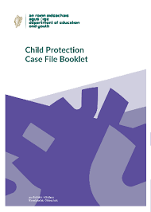
Child Protection Safeguarding Booklet
https://www.stsenansed.ie/sites/ss/assets/File/2026/Child%20Protection/Child_Protection_Safeguarding_Booklet.pdf
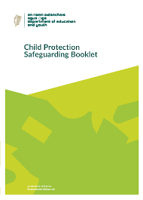
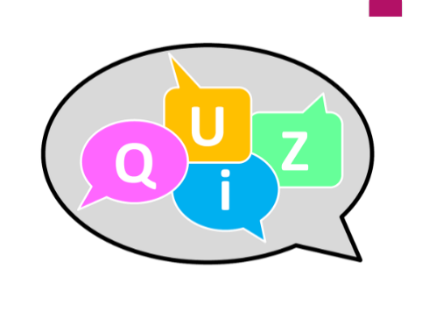

A short quiz that you may wish to use as a board moving forward as a refresher.

Q1. When must every Board adopt the Child Protection Procedures for Schools 2025?
A. By 31st December 2025
B. By 31st December 2026
C. By the next Whole-School Evaluation
D. Whenever the Patron reminds us

Q2. True or False: The DLP and DDLP must have completed full child protection training before taking up the role.
True — it’s a mandatory requirement under the 2025 Procedures.

Q3. If an allegation is made against the DLP, who becomes the DLP for that case?
A. The Deputy DLP
B. The Chairperson of the Board
C. The Patron
D. The Department of Education

Q4. What must appear as a standalone item at every ordinary Board meeting?
A. Principal’s report
B. Finance report
C. Child Protection Oversight Report (CPOR)
D. Parent Association update

Q5. A good Risk Assessment always asks three questions:
A. What’s happening, who’s to blame, who reports it?
B. What’s the issue, what’s the policy, what’s the cost?
C. What’s the problem, what can we do, who checks?
D. Who’s available, what’s easiest, what’s cheapest?

Q6. Confidentiality in child protection is…
A. A good idea, if time allows
B. Optional for experienced Board members
C. A legal duty and moral responsibility
D. Just about keeping gossip to a minimum

🌂 Bonus Question – for a smile
If the DLP is the person holding the umbrella in the storm, who’s the DDLP?
A. The one standing beside them, ready to grab it if needed!
B. The one asking where the umbrella came from
C. The one checking if it’s on the school’s asset register
D. The one taking a photo for the website

