Board of Management Training Notes
Child Protection Procedures for Schools 2025
Oversight • Safeguarding • Confidentiality
These notes support Boards of Management in understanding and fulfilling their statutory role in child protection and safeguarding.
It is designed to accompany Board training and reflects the requirements of:
• Children First Act 2015
• Child Protection Procedures for Schools 2025
Slide 3 – Child Protection Procedure Outline Pages 2 -4
Slide 5 - Oversight Page 5
Slide 6 – Confidentiality Page 6
Slide 9 – The Role of the Chair Pages 7 and 8
The primary focus throughout is the welfare and safety of children, and the Board’s role in oversight — ensuring that procedures are followed, without investigating individual cases.

Visit www.cpsma.ie for the latest training webinars and videos.

For guidance and support, Boards are advised to contact:
Catholic Primary School Management Association (CPSMA)
Advice Line: 01 629 2462
Child Protection Procedures for Schools 2025

https://www.gov.ie/en/department-of-education/policy-information/child-protection-procedures-in-schools/

Chapter 1 – Legal Framework
Sets out the laws underpinning child protection in schools:
Child Care Act 1991, Children First Act 2015, Criminal Justice Acts, Sexual Offences Act 2017, Coco’s Law 2020, OSMR Act 2022, Vetting Acts 2012–2016, FOI Act 2014.
Boards must comply with this legal foundation in all child protection matters.

Chapter 2 – Definition & Recognition of Abuse
Explains the four categories of abuse: neglect, emotional, physical, sexual.
Key principle: Tusla must be informed where there are reasonable grounds for concern.
No proof needed — Tusla assesses the concern.

Chapter 3 – Retrospective Allegations
Deals with disclosures by adults about abuse in childhood.
Must be handled sensitively.
If the alleged abuser poses a current risk, it must be reported to Tusla (and possibly Gardaí).
Such cases must be included in the Child Protection Oversight Report (CPOR).

Chapter 4 – Roles and Responsibilities
Duties of all school personnel: report concerns immediately to the DLP.
Board of Management: Appoint DLP and DDLP, ensure procedures are known and implemented, oversee compliance.
DLP/DDLP: First contact for concerns, record-keeping, reporting to Tusla, supporting children.
Patrons: Receive copies of CSS and annual review; must be informed if BOM fails to act.

Chapter 5 – Reporting of Concerns
Outlines how concerns must be reported:
By parents about their own child.
By others (parents, students, community) about another child.
Always go to the DLP (or Chairperson if DLP is the subject).
Parents/others can also report directly to Tusla.

Chapter 6 – How to Make a Report to Tusla
Reports made through Tusla’s secure web portal.
Urgent cases: by phone, followed by written report.
If Tusla unavailable and child is in immediate danger, contact An Garda Síochána.
Schools must know local Tusla contact details.

Chapter 7 – Allegations Regarding School Employees
Child’s welfare is the priority; staff member treated fairly.
Employers must take protective measures (e.g., temporary absence of staff).
Confidentiality is essential.
DLP must inform the employee privately, give details, and outline supports.
Immediate Action Protocol allows precautionary steps before investigations are complete.

Chapter 8 – Record Keeping
Every child protection concern generates a hard copy case file kept securely by the DLP.
Digital drafts must be deleted.
BOM receives only redacted/anonymised reports.
All copies distributed to the Board must be collected and destroyed.

Chapter 9 – Child Safeguarding Statement (CSS) & Risk Assessment
BOM must adopt, publish, and display the CSS and risk assessment.
Annual review required, with stakeholder feedback.
Must be available to parents, patrons, DEY, and on school website.
Also requires student-friendly version displayed in school.

Chapter 10 – Recruitment & Vetting
Schools must comply with Garda Vetting Acts.
Always seek references, especially from last employer (though not legally required to respond).
Additional checks for staff who lived in EU/UK (extra 10–20 working days processing).

Chapter 11 – Training & Supports
All school staff must attend child protection training every 3 years.
DLP and DDLP require specific training.
Refusal to attend may be a disciplinary matter.
BOM must ensure training records are kept.

Chapter 12 – Oversight (CPOR)
BOM must ensure procedures are fully implemented.
CPOR is a standalone agenda item at every meeting.
Covers allegations, concerns, bullying, reporting data.
BOM role: check compliance, not investigate.
Breach of confidentiality can lead to removal from Board and possible personal liability.



Chapters most relevant to the Board of Management

Chapter 4 – Roles and Responsibilities
BOM must appoint a DLP and DDLP.
Ensure they are supported and procedures are followed.
Ensure all staff are familiar with child protection procedures.
Patron oversight link also set out here.
Chapter 7 – Allegations Regarding School Employees
BOM has duties as the employer.
Must ensure protective measures for children, treat staff fairly, seek legal advice, and follow correct protocols.
Chapter 8 – Record Keeping
BOM only sees redacted/anonymised reports.
BOM must ensure strict confidentiality and proper handling of documents.
Chapter 9 – Child Safeguarding Statement (CSS) & Risk Assessment
BOM must formally adopt, publish, and review the CSS.
Responsible for annual review, stakeholder input, and ensuring display/public availability.
Chapter 11 – Training & Supports
BOM must ensure all staff (including DLP/DDLP) attend child protection training every 3 years.
Keep training records.
Chapter 12 – Oversight (CPOR)
Most central chapter for BOM.
CPOR must be a standalone item at every meeting.
Oversight role only — verifying compliance, not investigating cases.
BOM members must maintain strict confidentiality; breaches can lead to removal and personal liability.

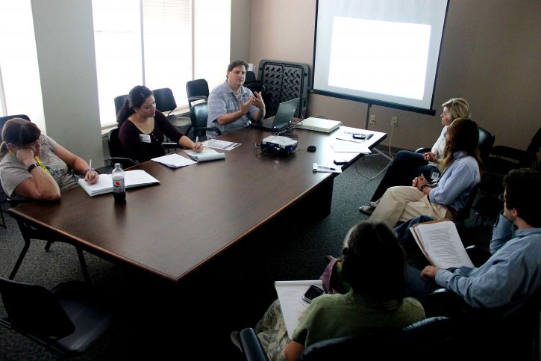

Oversight – What does it look like?

In ordinary terms, oversight means asking questions at Board meetings like:

Have the Board appointed a Designated Liaison Person and DDLP (Deputy DLP)?
Are safeguarding programmes such as SPHE and the Stay Safe Programme in place and delivered across the school?
Have the Board adopted and reviewed the Child Safeguarding Statement and Risk Assessment?
Do we review the Child Protection Oversight Report (CPOR) at every ordinary Board meeting?

Are the procedures been followed?

- Has the DLP sought advice or made a report where required?
- Are records being kept securely and confidentially?
- Are the right people trained, appointed, and supported?
The Designated Liaison Person – usually the Principal manages cases.
Tusla investigates.
The Board checks that the process was followed.

Practical examples of appropriate oversight questions at a Board meeting:

Board members may (and should) ask questions that test whether procedures are working, while avoiding any discussion of case details.

Examples include:

Have the Child Protection Procedures for Schools 2025 been formally adopted and minuted by the Board?
Are the Designated Liaison Person (DLP) and Deputy DLP properly appointed, trained, and supported?
Is SPHE, including the Stay Safe Programme, being implemented across all classes in line with Department requirements?
Have all staff and relevant volunteers completed mandatory child protection training within the required timeframe?
Is the Child Safeguarding Statement and Risk Assessment up to date, reviewed annually, and publicly displayed?

Questions relating specifically to cases presented in the Child Protection Oversight Report– focusing on procedure only:

Has the DLP sought advice from Tusla where required?
Where advice was sought, was it followed correctly and within the appropriate timelines?
Are records being kept securely and in line with the Procedures and data protection requirements?
Is the Board satisfied that confidentiality is being maintained at all times?
If the DLP has decided not to take advice from Tusla, what safeguards are in place?

Confidentiality – What does it look like?

Scenario
A parent approaches you and says:
“I heard there was a child protection issue in the school.”
.
Positive, Proportionate Responses

Board members should respond neutrally and reassuringly, without confirming, denying, or exploring the comment.

Example:

“Every school in the country has clear safeguarding procedures in place, and they’re always followed. If you have a concern, the right person to contact is the Principal or the Designated Liaison Person.”

When asked by a staff member or friend in the school:

“Board business is confidential, so I can’t talk about that outside a formal meeting.”
“It’s really important that I protect everyone’s privacy — so I’m not able to discuss Board issues, even informally.”

When you overhear or are drawn into gossip:

“I’m going to step away from this conversation — it’s not appropriate for me to hear or discuss school matters outside the meeting.”
“That’s not something I can comment on, and I’d rather not speculate.”
“If there’s a genuine concern, it should go directly to the Principal or DLP — that’s the right channel.

The Helpful Intention

A Board member wants to “check in” on a family after hearing that a report was made, thinking it would be a kind gesture.
Question:
Why is that a breach, even though the intention is good?
Key points:
It could identify the child or the concern.
It may interfere with a Tusla or Garda process.
It risks retraumatising the family or compromising confidentiality.
Even well-meaning actions can undermine the safeguarding process.

Closing reminder for Boards: Confidentiality isn’t about keeping secrets — it’s about protecting trust. When we hold information carefully, we protect children, respect staff, and honour the role of the Board

Chairperson Flowchart – Child Protection Procedures 2025
Children’s safety and welfare are the primary concerns at all times.
CPSMA Advice Line: 01 629 2462

PATH A – Allegation Against School Personnel (NOT the DLP)

Allegation / Suspicion Arises against School Personnel
CHILD SAFETY FIRST
Is any child at immediate risk?
→ Take urgent protective action if required

If the allegation reported to DLP……….
Remember the DLP records concern and consults Tusla
Informs Employer (Chair and Board)
Chairperson – Is there an employment issue? Are protective measures required?
Always contact CPSMA – 01 6292462
If the Chairperson does not agree with DLP action?
(For example - no report / no Tusla advice / advice ignored)
Chairperson seeks Tusla advice
Submits report or directs DLP
May convene emergency Board meeting
Board of Management
Oversight of procedure only
(No investigation or judgement)
If non-compliance with Tusla advice
Chairperson notifies Patron
END – Ongoing monitoring

↓Path B – Allegation Against the DLP
Allegation / Suspicion Arises against DLP
Always Ring CPSMA: 01 629 2462
Report DIRECTLY to Chairperson
CHILD SAFETY FIRST
Is any child at immediate risk?
→ Take urgent protective action if required
Chairperson assumes DLP role
Records concern
Consults Tusla
Reports / Mandated report as required
Safeguarding actions
Legal advice as required
Always Ring CPSMA: 01 629 2462
Board of Management
Oversight only
Strict confidentiality
END – Ongoing monitoring

