St. Senan’s Education Office

Vacancy for Assistant Director
One-year (minimum) fixed-term full-time contract

Serving the Patrons and Boards of Management of Catholic Primary Schools in the Catholic Archdiocese of Cashel & Emly and the Dioceses of Limerick, Kerry and Killaloe.

The successful candidate will work with the Director and team in the provision of necessary supports to further good governance and management in the Catholic Primary Schools in the Dioceses named above. Responsibilities include support of the Patrons in their dealings with management bodies, Trustees, Department of Education officials, Parents’ Representative groups, and other education partners; support and advice to Boards of Management on matters pertaining to the management of Primary Schools under the Catholic Patronage.

Range of Knowledge, Experience, and Skills required
The ideal candidate will possess a range of competencies and skills to support the role, in particular:
- A clear understanding of and commitment to the nature, principles and objectives of Catholic primary education.
- A thorough knowledge of primary education in Ireland.
- A clear understanding of the role of a Board of Management of a primary school under Catholic patronage.
- Excellent interpersonal skills.
- Excellent communication, presentation and facilitation skills.
- Evidence of ability to develop, compile, deliver and evaluate training programmes and presentations to a variety of audiences.
- Excellent organisational skills.
- High levels of writing and multimedia skills, including ICT skills.
- Leadership knowledge and skills.
- A strong work ethic.
- A good knowledge of the operation of schools and relevant legislation.
- Flexibility to meet the needs of the Office, including a willingness to engage in travel and/or evening work as necessary (there may be occasional overnight commitments).
- Knowledge of and commitment to Child Protection.
- A strong track record of previous achievement at a level commensurate with the position.
- Qualification/Experience in HR would be advantageous but not essential, but the ideal candidate will have a knowledge of employment legislation and issues and experience of negotiation and conflict resolution.
Special requirements
- Applicants should have a relevant qualification /significant experience in Education, Human Resources or Management.
- Full clean driving licence and own transport.
- Respect for the teachings of the Catholic Church and willingness to support the Catholic ethos in Primary schools.

Completed application form to be returned email to: recruitment@limerickdiocese.org by 5.00 pm on Friday, 29th April 2022.

Shortlisting and Garda Vetting will apply in respect of this position. A panel may be formed from the recruitment process that will expire after six months. Please note that incomplete or late applications will not be considered.

JOB DESCRIPTION

Position/Title: | Assistant Director, St Senan’s Education Office
Summary of the Service | Provision of necessary advice, supports and resources to the Archdiocese of Cashel & Emly and the dioceses of Kerry, Killaloe, and Limerick to:  - assist Boards of Management of primary schools, under Catholic patronage in those Dioceses, in the discharge of their governance responsibilities;  - assist the Patrons and Trustees in the discharge of their responsibilities to Diocesan Primary Schools.
Location: | Limerick Diocesan Centre, St. Munchin’s, Corbally, Limerick.
Reporting to: | Director, St. Senan’s Education Office.
Terms and conditions of employment: | This is a full-time, fixed term contract (minimum one-year).  Salary is commensurate with experience.  The position is based on a 35 hour working week. The nature of this role will require the holder of the post to be available to work in a flexible manner, operating a time-in-lieu system to facilitate the requirements of the post.
Main Duties | - Support and advise the Patrons of Catholic primary schools in the Archdiocese of Cashel & Emly and the Dioceses of Kerry, Killaloe, and Limerick in carrying out their functions and obligations under the Education Act 1998 (as amended); the Governance Manual for Primary Schools; Department of Education circulars; and any other relevant legalisation, circular or regulation.  - Support and encourage the Catholic Ethos of primary schools served by the Office.  - Assist and advise the trustees of Catholic primary schools in the Archdiocese of Cashel and Emly and the Dioceses of Kerry, Killaloe, and Limerick.  - Support and advise Boards of Management on the implementation of legislation, Department of Education circulars and directives, and agreed national policies and procedures in order to ensure the effective management of the primary schools served by the Office.  - Advise chairpersons and members of Boards of Management concerning the development and implementation of schools’ own policies and procedures.  - Support to chairpersons and Boards of Management in their dealings with Trade Unions, the WRC, and other relevant agencies.  - Development and delivery of training for Boards of Management.  - Collaboration with other relevant parties, e.g. CPSMA, Education Centres, & FSSU.  - Management of complaints concerning the governance of primary schools served by the Office.  - School visitation as required and necessary.  - Close engagement with the administrative staff.

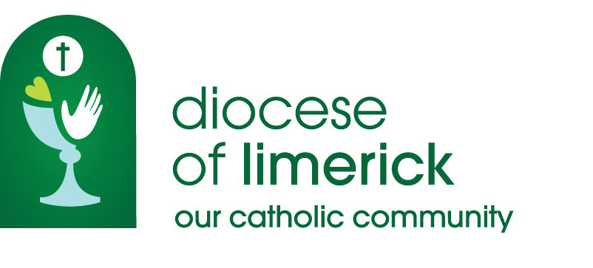

application form

Job Title Assistant Director, St Senan’s Education Office
Location Diocesan Centre, St Munchin’s, Corbally Limerick
Closing Date for Application Friday, 29th April at 5.00pm

Personal Details

Surname
Title
Forename(s)
Address
Eircode
E-mail
Tel. No.
Mobile
Current Salary
Where did you hear about this post?

Statement of suitability
Please provide a comprehensive statement of why you think your skills and experience are suitable for this role, (max 300 words)

Describe the skills & experience you possess in the following areas that would enable you to fulfil the role as described in the job description
Knowledge/experience of relevant legislation and policy
Experience of working collaboratively

Evidence of facilitation and/or training skills

Evidence of organisational and planning skills
Evidence of ability to work on own initiative as well as part of a team
Experience of ICT skills
Experience of negotiation and/or conflict resolution

Employment Record
Please list brief particulars of the positions you held and experiences you obtained. Start with your present or most recent employer. Provide reasons for any gaps in your employment. (You may wish to submit this information in a sealed envelope with your name and marked “Confidential”).
Dates |  | Employers Name, Location  and Type of Business | Duties, Status and Nature of Work | Reason for Leaving
From | To
Educational Background
University/  College | From | To | Courses and Results
Further Education and Formal Training | From | To | Courses and Results
School | From | To | Examinations and Results

Additional Information
Please indicate any additional information which you feel may be helpful in assessing your suitability for the position

References
Please include details of your current/most recent employer and two other referees, one of which should be a character reference. Referees must not be related to you. Referees will not be contacted prior to interview.
Name and Position of Referee | Capacity in which known to Referee | Address, E-mail  and Telephone Number

Are you an Irish citizen or national of any EU country? Yes No
Do you need a work permit to work in Ireland? Yes No

Declaration
To the best of my knowledge and belief the replies given to the questions on this application form are true and I have disclosed all information which I consider relevant. I hereby declare that there is no reason rendering me unsuitable to work with children or vulnerable adults. I understand that appointment will be subject to references, satisfactory Garda vetting and a medical. if I accept an offer of employment and any of the information is subsequently found to be incorrect, my employment may be terminated.
Signature of Applicant: Date:

Please complete all parts of this form and return by email to recruitment@limerickdiocese.org clearly marking the application Assistant Director, St Senan’s Education Office by 5.00 pm on Friday, 29th April 2022

