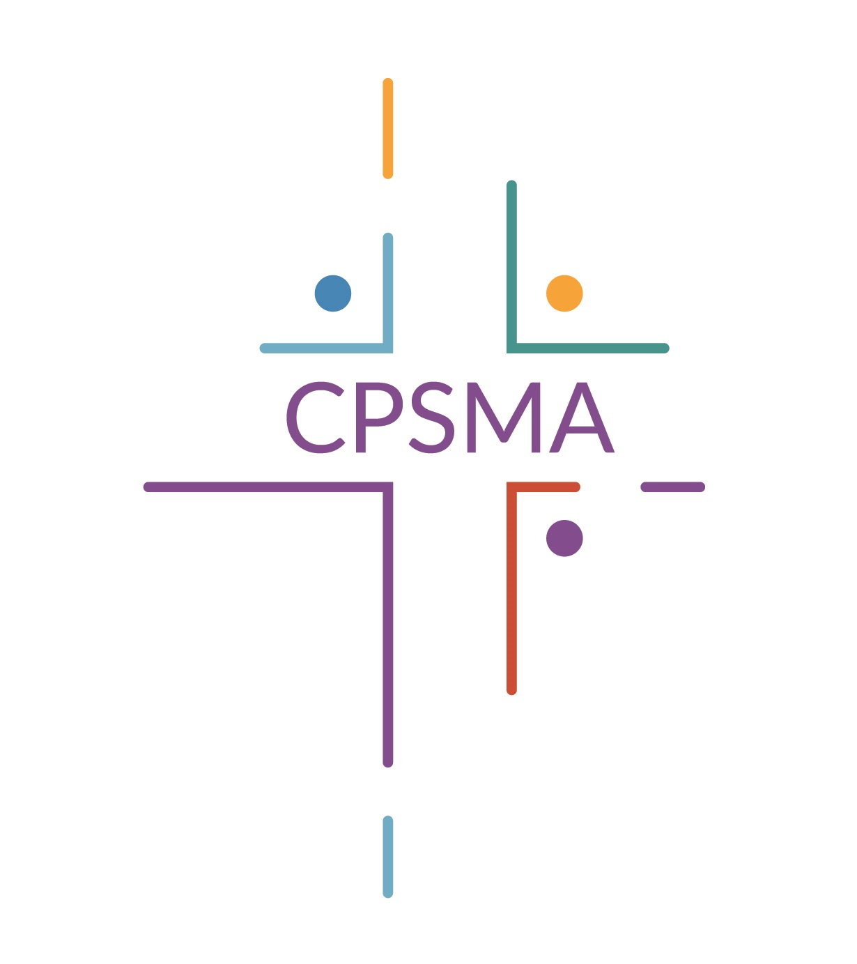 | Membership Form  2020/2021  Catholic Primary Schools Management Association  New House, St. Patrick’s College, Maynooth, Co.Kildare  Tel.: (01) 629 2462 Website : www.cpmsa.ie E-mail: info@cpsma.ie

Roll No. of School
Uimhir Rolla
Name of School
Ainm na Scoile
Postal Address
Seoladh Poist
Telephone of school
Fón
E-Mail
Ríomhphost
Principal Teacher  Príomhoide | Name/Ainm
Principal Teacher  Príomhoide | Phone/Fón
Chairperson  Cathaoirleach | Name/Ainm
Chairperson  Cathaoirleach | Phone/Fón
E-Mail/
Ríomhphost
Pupil Enrolment (30.09.19)
Daltaí cláraithe (30.09.19)
Diocese
Deoise
Amount Enclosed  Méid istigh leis seo |  | €
Please tick your chosen Method of Payment
  Cheque |  |  | EFT (Online banking) |  | Visa(Online Payment)
Please return the completed form to CPSMA, New House, St. Patrick’s College, Maynooth, Co. Kildare
This information will be stored by CPSMA for administrative purposes, i.e. the processing of membership applications, distribution of newsletters / e-zines and the invitation to participate in surveys of our member schools. The information will not be shared with a third party and will be retained by us for a period of 12 months.
Please contact CPSMA with any data related concerns you may have. In addition, you may direct any concerns or complaints to the Data Protection Commissioner at: 21 Fitzwilliam Square South, Dublin 2, D02 RD28.
Thank you for taking the time to complete this form.

