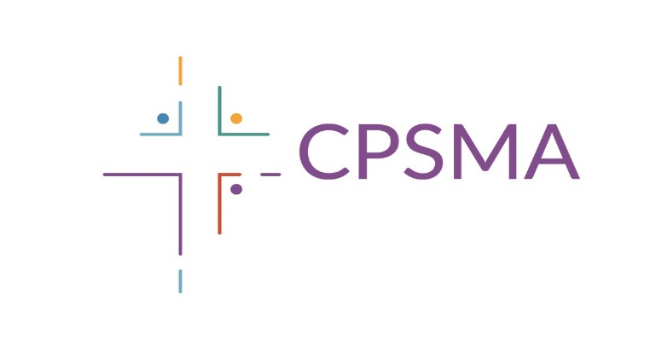

Please attach a completed entry form to the back of each entry

Category_________
Name ____________________________
School Name ____________________________________
School Roll Number _______________________________
School Address ___________________________________
School Telephone _________________________________
School Email Address______________________________
Teacher’s Name __________________________________
I certify that the attached work is the unaided original work of the child named above.

-------------------------------------------------------------
Signature of teacher or parent/guardian

Closing Date Friday 1st March 2019

Please note that the information contained in this entry form will be used solely for the purposes of the Art Competition and will not be retained by CPSMA after the competition has closed and prizes have been awarded.

