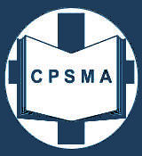
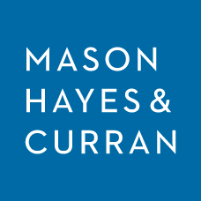
Seminar in conjunction with Masons Hayes and Curran

APPLICATION FORM
Name of Attendee
Role
School Roll Number
School Name
School Address | .....................................................................................................................  .....................................................................................................................  .....................................................................................................................
Mobile Number
E-Mail Address

Application form to be returned to ldunne@cpsma.ie

Please note that places on this seminar will be offered to the first 120 participants submitting complete application forms
Confirmation of acceptance at the seminar and will be issued via e-mail.

FOR OFFICE USE ONLY
Complete Application Form |  | Date Received |  | Number on placement list

